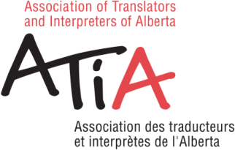
2025 ANNUAL GENERAL MEETING
NOVEMBER 1, 2025
CERTIFIED MEMBERS: If you are NOT attending the Annual General Meeting, it is important for you to send in your proxy form.
According to the By-laws of the Association, we need twelve (12) voting members in good standing to constitute a quorum at any annual or special meeting and written proxies, as provided for in Art. 11.3.1, count toward the quorum.
In naming a proxy, please choose a certified member or one of ATIA's Council Members that you know will be attending the meeting. It is important to confirm that this person is attending the AGM or your proxy will NOT count as quorum.
This year, the following Council members will be attending the Annual General Meeting: Perla Ben-Zvi, Samah Elzahaby, Russell Gillis, Mayada Tawachi, Samah Elzahaby, Tania Therien. Please note: Allison Downer is not a member of ATIA so she cannot vote.

PROXY

I, the undersigned, hereby appoint _____ , or failing him/her,
______, as my nominee to attend and act on my behalf at the Annual General Meeting of the Association of Translators and Interpreters of Alberta/Association des traducteurs et interprètes de l'Alberta, to be held ONLINE through Zoom on Saturday, November 1, 2025, with the power to vote as he/she sees fit on all matters that may properly come before the meeting.
Name:
Date:
Signature:
Please complete this form and submit it by the end of the day on October 31, 2025.
E-mail: admin@atia.ab.ca

