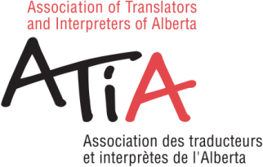
CALL FOR NOMINATIONS
FOR THE 2020 ANNUAL GENERAL MEETING OF ATIA
October 17, 2020

Candidates may file their own nomination, with the signature of one supporter.
The Vice-President, Treasurer, and Secretary positions are open to Certified Members only. Member-at-large positions are open to Associate members as well. Associate members may also participate in ATIA by supporting a candidate who runs for office or by joining committees. A description of the terms and responsibilities of each Council position is provided in the By-laws. For more specific information, contact one of the current position-holders or Allison Downer, the Administrative Assistant.
Elections will be held at the Annual General Meeting ONLINE through Zoom on October 17, 2020.

I, , the undersigned, would like to submit the following names, as candidates for the ATIA Council position indicated:

President: 2 years
Vice-President Northern Alberta: 1 year (second year of a two-term position)
Vice-President Southern Alberta: 1 year (second year of a two-term position)
Secretary: 1 year
Treasurer: 1 year [The present Treasurer has agreed to continue one more year]
OR
I, , the undersigned, would like to submit my name as a candidate for the following ATIA Council position:
___ | President: 2 years
___ | Vice-President Northern Alberta: 1 year (second year of a two-term position)
___ | Vice-President Southern Alberta: 1 year (second year of a two-term position)
___ | Secretary: 1 year
___ | Treasurer: [The present Treasurer has agreed to continue one more year]

Signature of Candidate Date

Candidacy of the above position is supported by:

Signature of Supporter Date

E-mail the completed form to Allison Downer, admin@atia.ab.ca; or
mail to PO Box 546 Main Post Office, Edmonton, AB, T5J 2K8

