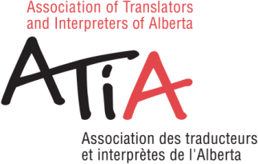
2022 ANNUAL GENERAL MEETING
OCTOBER 15, 2022

CERTIFIED MEMBERS: If you are NOT attending the Annual General Meeting it is important for you to send in your proxy form.
According to the By-laws of the Association, we need twelve (12) voting members in good standing to constitute a quorum at any annual or special meeting and written proxies, as provided for in Art. 11.3.1, count toward the quorum.
In naming a proxy, please choose a certified member or one of ATIA's Council Members that you know will be attending the meeting. It is important to confirm that this person is attending the AGM or your proxy will NOT count as quorum.
This year, the following Council members will be attending the Annual General Meeting: Roula Salam, Perla Ben-Zvi, Siyi Tonella, Laurice Mussallam.
Please note: Allison Downer is not a member of ATIA so she cannot vote.

PROXY

I, the undersigned, hereby appoint ______________________________________ , or failing him/her,
________________________________, as my nominee to attend and act on my behalf at the Annual General Meeting of the Association of Translators and Interpreters of Alberta/Association des traducteurs et interprètes de l'Alberta, to be held ONLINE through Zoom on Saturday, October 15, 2022, with the power to vote as he/she sees fit on all matters that may properly come before the meeting.
Name:
Date:
Signature:
Please complete this form and submit by end of day October 12, 2022.

E-mail: Allison Downer, admin@atia.ab.ca;

